A Brief History of the California Alpha Chapter
Of Sigma Phi Epsilon

Michael A. Green 62'

The Palomar Club and the Founding of California Alpha
The California Alpha Chapter of Sigma Phi Epsilon came from the Palomar House Club. Palomar was the twelfth of the thirty-one male house clubs formed on the Berkeley campus between 1874 and 1922. The last of these house clubs ceased operation in 1966. Little is known about the founding of the Palomar club. We do not know if the club came from an earlier group, but the evidence we have suggests that it did not come from an earlier group. The exact date of the Palomar Club’s founding is not known. We do know that the Palomar club was founded after Del Rey (November 1904) and before Calmedico (the fall of 1906). The 1906 earthquake and fire destroyed official records of Palomar’s existence before April of 1906 on April 18, 1906. From records at the national fraternity headquarters in Richmond, it is probable that the Palomar club was founded in late August or early September 1905, shortly after the 1905-1906 academic year started. It is known that the Palomar club was founded during the seventh year of Benjamin Ide Wheeler’s presidency of the University of California.
We do not know what kind of a house the Palomar club rented during that first year, nor do we know the location of that house. In fact we know nothing about the location of the Palomar club until the fall of 1909, when they were located at 2523 Hilligass, on the east side of the street in the block just beyond Dwight Way. One can only speculate what that first year must have been like. We are not sure even who was a member of the Palomar club during that first year. We do know that that first year was an exciting in one. At about 5 AM on the morning of April 18, 1906, the members of the Palomar Club were shaken from their beds by the worst earthquake in California history. Injuries, if any, were minor, since the houses in Berkeley at that time were of wood frame construction. Unlike San Francisco across the bay Berkeley did not catch fire. When the members of Palomar Club went on campus that morning, the shattered remains of the Bacon Hall tower greeted them. Bacon Hall was the third or fourth building built on the Berkeley campus. Its tower had a view of the bay over South Hall across the field where Sather Tower now stands. The Bacon Hall tower was torn down and the building was repaired. The University Library in Bacon Hall was opened as soon as possible. Bacon Hall with its round rotunda was torn down in 1960 to make room for Birge Hall an extension of the physics building LeConte Hall.
By 1907, the Palomar club had a membership of at least twenty-two brothers. The first mention of the Palomar Club in the Blue and Gold was in the yearbook published in the spring of 1907. The picture for the Palomar club shows nine brothers who are not identified. Since the pictures were taken in the fall of 1906, it is possible that the club membership was fewer than a dozen. By the spring of 1907 when the membership list had to be turned in, the membership list showed twenty-two members. This membership list included: Seniors; Winfield A. Benner, Chester F. Awalt, Thomas W. Winsor, Thomas T. Waterman, and Herman E. Rahlman; Juniors; Carrol M Lucus, Leland N. Barber, Orlando Bailey, Robert S. Sorenson, Cresten H. Jensen, and George McKinney; Sophomores; Herbert V. Harris, Robert L. Flannery, Carlton S. Rathbone, Fred Newton, Donald English, Charles H. Sturges, and Theodore E. Glazier; and Freshman; James Blacksill, Bert M. Carner, Leon E. Torrey and Carl Mendenhall. The total membership of the Palomar Club during its five plus years of existence probably did not exceed fifty. More than half of the members of the Palomar Club became charter members of the California Alpha chapter of Sigma Phi Epsilon.
Palomar was founded like most of the house clubs as a less snooty alternative to the fraternities. The members wanted the fellowship that a fraternity provided without the social stigma of belonging to an exclusive Greek organization. In 1905, many of the fraternities were rich man’s clubs. But given the kind of campus Berkeley was and the number of people, who belonged to fraternities, the bulk of the members of fraternities were not rich. The really wealthy Californians sent their children to Stanford or the Ivy League schools in the east. In any event, there was a perception that fraternities were exclusive and thus were not open to all. Fraternities had their secret rituals, their pledge programs, their hazing their pins and all of the other trappings that some considered to be a negative at the start of the progressive era. In reality, the house clubs were not much different than the fraternities. Most of the house clubs had rituals, and members went through a kind of apprenticeship similar to pledgeship. Most of the house clubs had pins and most of the other trappings of fraternities. As to hazing, all male freshmen were hazed. In fact most freshman had to wear some kind of a green funny hat that was later called a dink. It was considered to be right and proper that freshman had to be put in their place and trained to be a university man. Even though the University was only forty years old in 1908, the campus had very strong traditions. By 1908 the house clubs were already part of that tradition. Notable clubs were Bachalordon and Abracadabra.
Among the house clubs, Palomar was not remarkable. It was not old enough to have the traditions that Bachelorden (1894 to 1952) or Abracadabra (1895 to 1960) had. By 1909 or early 1910, many in the Palomar club felt that becoming a Greek letter fraternity might be a desirable thing to do. A couple of the house clubs had moved that way. In 1900 Sauer Bawl had become Phi Sigma Delta, a local fraternity that had become a chapter of Alpha Delta Phi and in 1909 Ridge Road (founded in 1900) became a chapter of Phi Sigma Kappa. The desire to become a fraternity was probably not universally shared by the membership. To those who founded Palomar, becoming a fraternity was probably a sell out. For example, older alumni like Thomas Winsor, Thomas Waterman, Carrol Lucas, Leland Barber, Herbert Harris, Carlton Rathbone, Charles Sturges and a number of the other early members did not join the fraternity Palomar Club became. The debate within the club in 1909 and 1910 must have been heated.
It is not known which fraternities talked to the members of Palomar Club nor is it known if the club really talked to any fraternity besides Sig Ep. The members of Palomar club, I have talked to do not recall how or when the club and Sig Ep became connected. There is some evidence that the first contacts between the Palomar Club and Sigma Phi Epsilon occurred in May of 1910. It is apparent from the records of the time that J. M. Price of the newly installed Kansas Alpha chapter was involved in the first contacts with the club. There were undoubtedly a number of letters between William L. Phillips the Sigma Phi Epsilon Grand Secretary and members of the Palomar club during the summer and fall of 1910. Copies of these letter do not exist, so we can only speculate what the letters looked liked or whether a formal petition for chapter status was ever filed. Petition became the norm by 1916, but it is not known if one was required for a group to become part of Sig Ep in 1910. It is clear that a club vote was taken in the fall of 1910. Virtually all of the active members and alumni were involved in the vote. It is clear that a majority of those voting chose to have the Palomar Club become a chapter in Sigma Phi Epsilon. Well over half of the total membership of the Palomar Club eventually became members of Sigma Phi Epsilon.
While it is not clear how the Palomar Club become connected with Sigma Phi Epsilon, we do know that the formal date of the chapter installation was Thursday November 10, 1910. The records of the fraternity are very clear on that point. The installation team for the California Alpha chapter consisted of brothers William L. Phillips of Virginia Alpha, Dr. L. H. Alton of Illinois Alpha and J. M. Price of Kansas Alpha. The initiation of the brothers of the new chapter occurred during the afternoon and evening of November 10th. The chapter charter was presented to the president of the Palomar Club Benjamin H. Maddox and the brothers of California Alpha at 11 PM in the evening. The initiation and presentation of the charter occurred in the rooms of the Palomar Club at 2523 Hilligass in Berkeley. California Alpha became Sigma Phi Epsilon’s thirty-fifth chapter and Sigma Phi Epsilon became the twenty-sixth national fraternity on the Berkeley campus. With the installation of California Alpha, Sig Ep’s first chapter west of the Rocky Mountains, Sigma Phi Epsilon truly became a national fraternity representing all parts of the country. By the end of 1910 Berkeley already had one of the largest Greek systems in the United States.
Robert L. Flannery 09’ was the first initiate of California Alpha. Other charter members were; James Blacksill 10’, Benjamin H. Maddox 11’, Artemus D. Wilcox 11’, Henry G. Thiel 11’, Ulysses S. Attix 12’, Edwin A. Abeel 12’, Fredrick C. Black 12’, Robert T. Aitken 12’, Arnold C. Dickel 13’, Donald C. Bennett 13’, Jesse R. Newton 13’, William F. Ball Jr. 13’, Creston H. Jenson 10’, Lindley D. Gilbert 10’, Robert S. Sorenson 09’, Chester F. Awalt 07’, George T. McKinny 11’, Herman E. Rahlman 07’, Ernest S. Scheninger 14’, Henry C. Compton 14’, Oscar Bailey 14’, Harrington W. Cochran 14’ and Carl L. Thiele 14’. It is clear that the old members of Palomar were initiated first and the class of 1914 was initiated last. It is not clear why Flannery was chosen as the chapter’s first initiate. By tradition, California Alpha has included all Palomar brothers initiated into Sigma Phi Epsilon as part of the charter group of brothers. Those charter members of California Alpha (all former Palomar Club members) not initiated on November 10 1910 include (in order of initiation); Theodore E. Glazier 09’, Tyson Harris 13’, Charles Anderson 12’, Guy Barker 14’, Theodore E. Dickel 10’, Bert M. Carner 10’, Robert M. Haskell 10’, Donald English 09’, Orlando H. Bailey 11’, Winfield A. Benner 07’, Leon E. Torrey, Halbert T. Johnson 10’, and Fred Newton 09’. Fred Newton, the last Palomar member initiated into Sigma Phi Epsilon, first wore the heart ten years after California Alpha was chartered.
On the following day (the 11th), in honor of the installation, the chapter entertained many of its friends and among them many faculty including the president of the University of California Benjamin Ide Wheeler. After the university community open house on November 11th, the brother celebrated their installation of their brotherhood, by taking the ferry to San Francisco where they had their installation banquet at the Ritz Old Poodle Dog Restaurant. After the banquet, the Grand Secretary William L. Phillips gave a brief outline of the growth of the fraternity. Brother J. M. price talked about the chartering of Sig Ep’s thirty-fourth chapter, Kansas Alpha at Baker University. Brother Price talked about the brotherhood he had found at other chapters he a visited across the country. The banquet, which lasted well into the night, was a success and all of the brothers returned to the house happy with the occasion. An interesting historical note: The Ritz Old Poodle Dog, which lasted well into the 1960’s, was one of San Francisco’s infamous French restaurants. In the early part of the twentieth century, the Ritz not only provided the finest food and finest wines to the gentleman of the San Francisco, but they also provided other services, in the French manor, to the gentlemen of the city in more private surroundings upstairs. It is not known if the Ritz still provided these service in 1910, so one can only speculate if the chapter founding brother did anything but eat and drink at the restaurant. Drink the brother probably did. Unlike Berkeley, which had been dry since 1883, San Francisco was a wide open city, with saloons.
The day after the installation banquet in San Francisco, was Big Game. The 1910 Big Game was held during the period between 1905 and 1914 when American football was banned from the Stanford and Berkeley campuses. During those years, the Big Game was a rugby game. This did not seem to dampen enthusiasm for the game. Over 23000 people watched the 1910 Big Game at Berkeley (a record until the stadium at the foot of campus was enlarged in 1914 to hold 26000). The game was scheduled to start at 2:30 in the afternoon, but it was delayed because several thousand people tried to scale the south fence of the field. The police cleared the people off of the fence. It was reported that one fan was offering $40 for a single standing room ticket; he found no takers and didn’t get to see the game. The 1910 Big Game saw the first card stunts (from the Cal side of the field naturally) ever performed at any athletic contest in the United States. Cal beat Stanford 25 to 6. For the brothers of Sigma Phi Epsilon’s newest chapter, it was a very good weekend.

California Alpha 1911 to 1923
The chapter grew and prospered until 1917, when the First World War affected all Berkeley fraternities. California had at least one athlete of note between 1911 and the start of the First World War. His name was Karl Shattuck a trackman who graduated in 1914. In 1914 he was the best hammer thrower in the United States. He didn’t try out for the US 1916 Olympic team because he could not afford to leave a job and travel to the Olympic trials in Eastern part of the United States. The first member of Sigma Phi Epsilon killed during the First World War was a member of California Alpha. C. Lewis Robertson ‘15’ died while fighting for Canada on the Western front where he was an infantryman.
The chapter had three outstanding men from the class of 1918. Two of these men were Orville Caldwell, a thespian at Berkeley during his undergraduate years (Orville later became a movie star during the era of silent film.) and Walter Escherich who later became the owner of a large construction company in Los Angeles. Third distinguished member of the class of 1918 was Arthur Sampson who became who later headed the College of Forestry at the University of California at Berkeley.
The First World War reduced the chapter size to seven men. The chapter had to give up its house on Euclid in September of 1917. From September 1917 until August 1918, the house was on Bevenue. They did not provide any board during that period. During the epidemic of 1918 and 1919, the chapter operated sub-rosa out of the home of C. H. Jenson of Berkeley. Most of the members lived in apartments on Bancroft. During that period all fraternities were prohibited from having meetings or social events. Somehow California Alpha remained active despite the restrictions from the university and the Department of Health.
During this period, Dr. Robert Aiken, (the father of one of the chapter founders (and an honorary member) became the director of the Lick Observatory, which at the time had the largest telescopes in the world. He was one of the leading scientists at the University of California and one of the top astronomers in the world.)
In August of 1919, the chapter moved to a house on the 2500 block of Channing Way near Telegraph Avenue, in Berkeley. Once the war was over the chapter grew and became a fraternity where a number of Athletes resided. One of those was Larkin (Bum) Bailey, a World War I veteran who played baseball for the Golden Bear baseball team. The rules during the early 1920’s were strict. Freshman had lockout and to be in their room and studying at 7 PM. By the time a man was a senior, he was allowed to stay out until 1 AM. There was no alcohol in any fraternity at Berkeley. This was due to prohibition and a long tradition of Berkeley being a dry town. If a man wanted to go to a saloon before prohibition on had to go to Oakland. During prohibition, the speakeasies were located in Emeryville or Richmond. In the fall of 1923, the chapter moved to a small house on Piedmont next to where Memorial Stadium was being constructed. This house had a sleeping porch with triple bunks. It was so noisy from the construction of Memorial Stadium one could not study. The chapter lived in this house until their new chapter house a 2728 Durant (across from Kappa Alpha Theta) was finished.

The 1920’s and 1930’s from 1923 to 1938
From November 1923 until the late spring of 1938, California Alpha occupied a house that they built at 2728 Durant Avenue in Berkeley. This house was one of the finest fraternity houses on the campus. It was one of the few chapter houses during that era that did not have sleeping porches.
The remainder of the 1920’s was a golden period for California Alpha. Sigma Phi Epsilon was a house where some of the best athletes on campus lived. The fact that the athletes were members of California Alpha was one of several factors that caused the chapter to lose the house during the depression in 1938. In the 1920’s and 1930’s, the fraternity houses provided board and room for the best athletes on campus. Because these men were star athletes the chapter was expected to provide room and board in exchange for about 15 hours a week of work for the house. California Alpha had so many of these athletes, the chapter suffered financially during the 1930’s.
The chapter provided leadership to many of its members. Some of the most accomplished alumni of the chapter lived in the chapter house during this period. Alumni from this period include Reginald Biggs (president of Emporium Capwell), Richard Stumm, Walter Plunkett (a costumer who was nominated for an Academy Award for Gone with the Wind in 1940 and won the Academy Award in the 1950’s for American in Paris), Milton Kaye (an air force general), Hubert Blunk (Hilton Hotels), Howard A. Schirmer (an world famous engineer), Robert Ryan (a southern California banker), Eric Stanford (White House departments stores), James Corley (Vice President of the University of California), Harold J. Powers (California Lt Governor), Gordon Huber (President of Huber Paper and a Bay Area philanthropist), C. Norman Peterson (president of the construction company that built most of the freeways in the San Francisco area) , Alva Regan (Track Coach at UC Berkeley), Robert S. (Skinny) Johnson (assistant to UC presidents Robert Gordon Sproul, Clark Kerr, and Harry Wellman (a Sig Ep from Oregon Alpha)), John Finger (attorney and President of the California bar), Eugene McAteer, California state Senator. California Alpha even had a don of the mafia, Leland Cerruti. (This was reported in Look Magazine during the 1950’s, but it was never proven.) He owned a number of auto dealerships in San Jose.
The athletes of that period included three first team All American football players; Roy (wrong way) Riegels, (Roy Riegles is known most for running the wrong way in the 1929 Rose Bowl.) Eugene McAteer, and Sam Chapman. Sam Chapman also played baseball for the Philadelphia Athletics. The chapter had a number of all conference football players and athletes of note in other sports. The California Alpha chapter had two gold medalists in the 1928 Olympic games (Hubert Caldwell and Alvin Rylander on the 1928 crew (eights with coxswain)).
The depression hit California Alpha hard. The chapter lost the house that was built in 1923 for $67000 because they could not pay $12000 to save the house. Delta Zeta sorority came up with the $12000 in the spring of 1938 and took over the house that Sig Ep built at 2728 Durant. In the spring of 1938, the California Alpha chapter of Sigma Phi Epsilon merged with the Gamma Beta chapter of Theta Upsilon Omega (TUO) when the two national fraternities merged.
Three members of California Alpha from this period became grand president of Sigma Phi Epsilon and became recipients of the Order of the Golden Heart. They were James Corley 26’ (GP from 1937 to 1940), Robert Ryan (GP in 1948-49) and Larkin Bailey (GP in 1949-50). Hubert Blunk received the Sigma Phi Epsilon citation for being the Vice president of Hilton Hotels. Walter Plunkett who won an Academy Award for costumes in American in Paris in 1950 (He was nominated for an Academy Award in 1940 for “Gone with the Wind.”) He was nominated for the Sigma Phi Epsilon Citation, but didn’t receive it because he couldn’t come to the conclave.

The Tilicum Club and Theta Upsilon Omega
California Alpha is one of four chapters of Sigma Phi Epsilon that has more than one origin. The second root of California Alpha is through the Tilicum Club and Theta Upsilon Omega (TUO). California Alpha was founded from one of the Berkeley house clubs, the Palomar club in 1910. The second root of California Alpha came from the Tilicum club a house club founded in November 1913. From the spring of 1914 until 1925, the Tilicum Club was located on Durant Avenue in Berkeley just above Bowditch Street. For some reason the Tilicum Club managed to hang on to its house during World War I and the Flu epidemic that followed. Since the Tilicum club was a house club instead of a fraternity, the restrictions on meetings may not have been the same as it was for the fraternities. Notable alumni of the Tilicum Club include; Samuel Pleasants (later a national officer of TUO), John Graves (a California democratic candidate for governor who lost to Earl Warren (also a UC Berkeley graduate) twice. (Nobody could beat Warren at that time.) Earl Warren later became Chief Justice of the US Supreme Court.
In March of 1925, the Tilicum Club became the Gamma Beta chapter of Theta Upsilon Omega (TUO’s 12th chapter). TUO remained in the Tilicum Club house on Durant until 1927. In 1927 and 1928, TUO had houses on Bancroft Way and College Avenue. In the winter of 1928, TUO moved to a house they built on the north side of the Berkeley campus on LeConte. TUO stayed in that house until the merged with California Alpha in 1938.
TUO provided the fraternity with a number of well-known alumni. These included: Maury Reed (founder of Masson McDuffy Real Estate), Clarence Betz, and Felton Turner (an early Bay Area aviator). There were a number of athletes of the 1920’s and 1930’s who were TUOs. These included Bert Griffen (football), the four Gill brothers from 1928 to 1932 (football players at Cal), and David DeVarona (football with Sam Chapman and Eugene McAteer).
In the early spring of 1938, TUO and Sigma Phi Epsilon merged. The California Alpha Chapter moved from its house on Durant Avenue to the TUO house on LeConte. In the fall of 1939, the TUO house was lost. The chapter moved to another house on LeConte that had been occupied by Zeta Tau Alpha. Zeta Tau Alpha moved to the south side of campus to a house on Warring Street.

California Alpha 1940 to 1970
The California Alpha chapter stayed in the old Zeta Tau Alpha house on LeConte Street from 1939 to 1945. Sigma Phi Epsilon was one of the eighteen fraternities that remained open during World War II. After the war, when the GI’s returned to school, the chapter moved into a house on the corner of College Avenue and Bancroft, where the Boldt Law School is now located. It was said that Sigma Phi Epsilon had the best bar on campus. The fraternities on campus were dry until 1941, but after the war everyone drank. The chapter during that period did produce successful alumni including a number of doctors and lawyers. In the early 1940’s, Melvin Mott graduated from Berkeley (he later became a professor on campus.) Bruce Dunwoody 48’ became a Vice President of Bethlehem Steel. The chapter was quite successful until the spring of 1950, when the university took over the house on Bancroft. The chapter moved to another university owned house Hearst, which later became a parking structure. From the fall of 1951, to the spring of 1956, the chapter was in a brown-shingled house once owed by Alpha Phi. This house was one of the few that didn’t burn down in the fire of September 1923. The chapter did not do well in this house.
In the fall of 1956, California Alpha moved to 2316 Bowditch. Sigma Alpha Epsilon built this house in 1898 and it was a dump. To those alumni that lived there, the house had redeeming features. The house had a basement that could be flooded for parties. In fact it was an excellent house for parties. The chapter membership reached a low point in the spring of 1957. That fall, with the help of Bill Tragos (the traveling secretary of the western region and Pete Peterson (a Hollywood attorney), the chapter pledged twenty men during the worst influenza epidemic since 1918. (Both Pete Peterson and Bill Tragos became Grand President of Sigma Phi Epsilon. This started California Alpha on an upward trend. Sig Ep was the top fraternity in intermurals for a number of years. The chapter was between 3rd and 6th in scholarship out of 55 fraternities during the late 50’s and during the 60’s. During the 1950’s and 1960’s, the chapter had a number of ASUC senators and Tom Hobday was president of IFC (after being chapter president). The chapter even had a few notable athletes. Stuart Gould was the Pacific Coast Conference top 440 man and Ralph Udick was the coxswain of the national championship crew that missed getting into the 1960 Olympics by one seat. California Alpha had men in crew, tennis, track, crew and rugby. California Alpha celebrated it 50th anniversary on 10 November 1960. A number of the chapter founder attended the celebration.
The chapter had a number of men who became physicists, engineers, biologists, chemists, doctors and lawyers. A number of successful businessmen came from the chapter as well. Successful alumni include; Rod Thomas (senior manager of the Idaho National Laboratory), Gaelen Rowell, (nature photographer and climber), Howard Schirmer Jr. (Partner in Dames and Moore and CEO of one of the C2HM Hill Companies), Tom Hobday (partner and manager of the largest insurance firm in the Central Valley and later chief fundraiser for the University of California Medical Center at Davis), George Federoff (US navel Intelligence), Dan Ford (a producer for NBC television and now an independent producer), and Frank Isola (president of one of the Franklin Mutual Funds).
The 1960’s brought the free-speech movement and many other demonstrations, many of which became violent. Ronald Regan won the governorship of California because he wanted to clean up the communist mess on the Berkeley campus. Many parents (particularly the parents of people who might join Greek organizations on the campus) refused to send their children to Berkeley. In the late 1960’s and 1970’s, UC Berkeley was the campus that students were redirected to. The violence escalated with the burning of Wheeler Auditorium and the breaking of thousands of windows on campus. The Peoples Park riots resulted in the death of one demonstrator. This was not a good time for fraternities nationally, but Berkeley was very hard hit. Membership in the Greek system plunged from 3300 in 1965 to less than 500 in 1971. Over half of the fraternities and sororities closed during this period. California Alpha moved from 2316 Bowditch to a house on Durant (next to the house built by Sig Ep in 1923). The move was a disaster. The alumni board closed the house in 1970. Had the chapter stayed in the house at 2316 Bowditch, the chapter would have survived on the campus. After sixty-two years of existence, the chapter went dormant in 1972. The Sigma Phi Epsilon national fraternity board of directors decided to never go back to Berkeley.
One member of California Alpha from this period Michael Green was a recipient of the Order of the Golden Heart in 2005. There are no Sigma Phi Epsilon citation recipients from this period. A couple of brothers have been nominated.

Re-chartering the Chapter; the Chapter from 1983 to 2002
The national fraternity was slow at re-chartering the chapter at Berkeley. Most on the national fraternity board were reluctant to put a chapter back at Berkeley given the radical nature of the campus during the late 1960’s and the early 1970’s. The Greek system at Berkeley didn’t start to recover until 1975. Only at that point did fraternity and sorority chapters start to come back. By this time all of the north side fraternities were gone. Except for a local fraternity that had been a chapter of Alpha Chi Rho. The last sorority on north side left in 1956. What had been fraternity and sorority houses on the north side of campus became part of the divinity schools on the north side of campus. By 1980, the city of Berkeley refused to allow Greek organizations to return to the north side of the campus. As a result, all of the fraternity and sorority houses were located on the south side of campus. The reemergence of the Greek system was different for fraternities than it was for sororities. If a sorority sold its house in the late 1960’s or early 1970’s, it was never able to reestablish a chapter at Berkeley. Fraternities could make do with rental housing, so many chapters that had sold their houses returned in rented houses later.
The standards of fraternity housing had changed. Fraternity houses became dumps with cheap rent and a lot of deferred maintenance. This still persists today. Sorority houses at Berkeley have always been well kept and well maintained.
The first serious discussions concerning re-chartering at Berkeley started in the late 1970’s. Past Grand President Robert L. Ryan was urging the fraternity board to act on re-chartering at Berkeley. Re-chartering at Berkeley had to wait until the national fraternity decided that it was important for Sigma Phi Epsilon to have chapter at the nation’s most prestigious universities. Since Berkeley was one of those universities, the decision was made to re-colonize in the spring of 1983.
The core of the new colony consisted of five members of existing Sig Ep chapters. The president of the colony was from Virginia Alpha. Dennis Chin a charter member of California Mu at Pomona became a key person in the alumni boards of the chapter in the years that followed. In the fall of 1983, an alumni board was formed and Mike Green was elected it president. He had served on the alumni board in the 1960’s. He served on the alumni board for ten more years from 1983 to 1994. In the fall of 1984, the chapter moved into its old chapter house at 2316 Bowditch. The chapter membership quickly shot up to 55, making Sigma Phi Epsilon one of the larger fraternities on the campus. As in the 1960’s the chapter was one of the top fraternities in grades, well above the all men’s average. The chapter wanted to re-charter on its original founding date of November 10th. Headquarters told the chapter that November 3rd was better because UCLA was to be chartered on November 10th. UCLA ended up getting chartered on November 3rd because the people at headquarters thought California Alpha was going to be re-chartered on it founding date of November 10th. As a result, most of the national fraternity dignitaries ended up at UCLA.
The keynote address at the re-chartering banquet was given by Bruce Hasenkamp a long time mentor to California Alpha from his days as the District Governor of Northern California and Nevada. Grand President Frank Ruck visited Berkeley on November 4th. There was a mix-up due to Frank being directed to the wrong campus building. The relationship between headquarters and the chapter got off to a bad start.
Despite a lurching re-chartering, the chapter was very good during the mid to late 1980’s. The chapter membership reached 95 in 1987. This is the largest membership that California Alpha ever had. At the time, Sigma Phi Epsilon was the largest fraternity at Berkeley. The next largest fraternity on campus had a membership of 85. California Alpha had a number of ASUC officers including Steve Ganz, student body president in 1986. Sigma Phi Epsilon also was tops in intramurals and in the top five out of forty fraternities in scholarship. The chapter grade point was above a 3.0. The chapter performance didn’t quite meet the standards for a Buchanan cup. The chapter always managed to do something wrong during this period.
In 1987 the national fraternity purchased a 68-man house (a house built by Phi Mu sorority in 1960) at 2425 Prospect Street. The neighbors managed to stop the fraternity from getting a use permit on a street that already had a number of fraternities on land that was zoned for fraternities. Thanks to the efforts of a number California Alpha alumni the appeal to the Berkeley City Council was successful, despite the fact that most of the members on the council wanted to do away with fraternities. Key in the effort to get a use permit for the chapter were “Skinny Johnson’ 1928 and Harry Wellman the former president of the University of California (a Sig Ep from Oregon State).
Unfortunately, 1987 represented a peak year for fraternity membership at Berkeley. With a change in student demographics between 1987 and 1990, (white students at Berkeley dropped from 70 percent to about 40 percent) the membership in Greek organizations plunged. The membership of the chapter declined from the low 90’s to the low 60’s. As a result, the chapter couldn’t keep the house full. Despite, the reduction in the number of members, the chapter remained active and was considered to be on of the best fraternities at Berkeley. In fact, the chapter won the Chancellor’s Cup for being the best fraternity on the campus twice during the first half of the 1990’s. California Alpha had a number of varsity athletes and remained very good in overall scholarship. One brother from the chapter won a Sigma Phi Epsilon national scholarship.
In 1993, the chapter moved from 2425 Prospect to 2395 Piedmont Avenue to 2395 Piedmont Avenue (the Phi Gamma Delta house). The chapter did reasonably well in this house. They even won the Chancellor’s cup when Jesse Diaz was president. The chapter scholarship remained high and the chapter continued to do well in intramural athletics. Several attempts were made to have the chapter become a Balanced Man Chapter. There were never enough votes to make it happen, so California Alpha remained an old style chapter with a pledge program. There were many in the chapter who could see the advantage of the new program, but there were too many in the chapter who wanted Sigma Phi Epsilon to be just like the other fraternities.
There are a number of alumni from this period who are destined to do well in life. The chapter has produced a number of engineers, doctors and lawyers during this period. There are some successful businessmen in this group of brothers. It is too early to see how well some of these men will do. There are at least two millionaires among the men who were in the chapter from 1983 to 2002.
The chapter lost the house a 2395 Piedmont in the spring of 2001, because Phi Gamma Delta decided to re-charter and they wanted their house back. There were no available houses for rent. The chapter membership fell to 25 in the spring of 2002. The chapter reputation was still good on the campus despite the fact there was no house. The chapter remained in the top five in scholarship with a grade-point average of more than a 3.0. The chapter was put on notice in the spring of 2002 that they were to bring their membership up to forty or they could lose the charter in the fall of 2003. In September of 2002, the chapter voted to return the charter to the national fraternity rather than try to bring their membership up.

Re-colonization and Re-chartering 2003 to 2006
The return of the charter in 2002 surprised headquarters. When the traveling man from headquarters went to the university, he found that Sigma Phi Epsilon had a good reputation and the university was sorry to lose Sig Ep. This was not the usual frat-rat situation where headquarters would wait for three to five years before trying to bring the chapter back. It was decided at headquarters that Berkeley could be re-colonized as a Balanced Man Sigma Epsilon Chapter (SEC) immediately. As a result, the Berkeley SEC had members at both the 2003 and 2005 conclaves. The Balanced Man program is the kind of program that the new group needed. The Balanced Man program emphasizes sound mind and sound body. Mentorship is the key to sustaining membership.
The primary problem with the new group was getting its membership up and getting the group into a suitable housing situation. The new group of men was not the type of men who normally joined fraternities at Berkeley. The Balanced Man program has permitted California Alpha to recruit men who are among the best on the Berkeley campus. These men tend to excel in all ways.
The men who formed the Berkeley SEC chapter had top grades a 3.3 grade-point average for the chapter. The men all had at least one other activity besides the fraternity. The Berkeley SEC group abounded with leadership. In 2005, the chapter was top in scholarship, top in philanthropy and a candidate for the Chancellor’s cup even though they were not yet a recognized fraternity. In every respect the SEC group founded in the spring of 2003 was a top performer.
In the late spring of 2005, the SEC chapter moved into a Julia Morgan house at 2901 Channing Way (on the northwest corner of Channing and Warring). The chapter had it first successful alumni function to celebrate the 95th anniversary of the founding of California Alpha and the 100th anniversary of the founding of the Palomar Club. The SEC chapter had a good reputation with the university and among fraternities and sororities on the Berkeley.
The chapter was re-chartered on November 10th, 2006 on the 96th anniversary of the chapter’s founding. The chapter re-chartering was done by Archer Yeats the Grand President of Sigma Phi Epsilon between 2005 and 2007. The chapter at Berkeley has had a couple of members attend the Ruck Leadership Institute in Richmond Virginia. One Chapter brother went on the Quest for Greece in 2007. The California Alpha chapter has won the Chancellor’s cup for two years in a row. In 2008 the chapter won most of the awards at the 2008 Greek awards ceremony. Mike Green got an award from the University of California for his contributions to the Greek community in Berkeley. Sigma Phi Epsilon has been the best chapter in terms of fund raising for charity. It is one of the top fraternities in inter-murals. The chapter scholarship remains high, but its relative ranking in scholarship has fallen, because the scholarship has risen among the Greek community. The Greek community in Berkeley has become much improved over what it was in past years. The California Alumni Volunteer Corporation has grown and most are fully trained in the correct procedures for helping the chapter improve and maintain its operations.
California Alpha wants to celebrate its 100th anniversary as the top fraternity on the Berkeley campus and as one of Sigma Phi Epsilon’s best chapters. There are many challenges for the new chapter to meet that goal. The California Alpha Chapter will celebrate it 100th anniversary on 10 November 2010. The alumni of the chapter will be invited to participate. The event will be chaired by the same person that chaired the 50th anniversary event for the chapter.

California Alpha Hall of Fame (a partial list)

Athletic Hall of Fame
Karl Shattuck ‘14’ All American in Track US record holder in the hammer throw. He did not enter the Olympic trials in 1916, but should have. He could not afford to go to the trials.
George Reed ‘25’ He was on of the best all around athletes at Cal during the 1920’s. He played football, boxed and swam for Cal. He had to give up crew because it interfered with his studies.
Gordon Huber ‘26’ All Conference player on the Cal football Team
Bert Griffin TUO’27’ Captain and All Conference on the Cal football team
Elmer Gerken ‘27’ One of California’s best track men of the 1920’s
Alvin Rylander '28' Olympic Gold Medal in Crew in 1928
Hubert Caldwell '29' Olympic Gold Medal in Crew in 1928
Roy (wrong way) Riegels '29' All American footballs player for California. He is infamous for running the wrong way in the 1929 Rose Bowl.
George Anderson ‘36’ California’s best track man from the 1930’s. Jesse Owens beat him to keep him out of the 1936 Olympic Games.
Eugene McAteer '37' All American Football player for California
Sam Chapman '38' All-American Football player for California, He is in the National Football Hall of Fame. He played major league baseball for the Philadelphia Athletics.
David DeVarona TUO ‘39’ He was part of the Thunder Team with Sam Chapman and Eugene McAteer. He was All Conference and perhaps All American as well. He was also a member of the Cal Crew.
Stuart Gould ‘59’ All conference in the 440 yard dash. He was one of the best quarter milers in the country.
Ralph (Troll) Udick '60' He was the coxswain for NCAA Collegiate Champion Crew 1960. He missed getting in the 1960 Olympic games by one seat and as a result he had to spend five days in jail for speeding.

Alumni Hall of Fame
Dr. Robert Aitken '1885' Professor of Astronomy at the University of California, and director of the Lick Observatory in the 1920's
Samuel Pleasants TUO ‘14’ He was an Arch Officer of the Theta Upsilon Omega national fraternity 1936 to 1938.
C. Lewis Robertson ‘15’ First member of Sigma Phi Epsilon to die in World War I while fighting for France
Orville Caldwell '18' He was a star of the silver screen (silent era). He was proclaimed to be the perfect man by Eleanor Glynn. Later he was the Vice-Mayor of the City of Los Angeles.
Dr Author Sampson '18' Professor of Forestry UC Berkeley, headed the School of Forestry at Berkeley for a number of years
Walter J. Escherich '18' Builder and large contractor in Los Angeles, founded the Escherich Brothers Construction Company in Los Angeles
Reginald Biggs ‘22’ He was president of Emporium-Capwell Stores before they were taken over by Macy’s.
Richard A. Stumm '22' President of Consolidated Pipe and Supply Company in Los Angeles
Walter Plunkett '23' He was a costumer for Hollywood, Broadway and the Metropolitan Opera in New York. He costumed over 270 films between 1926 and 1966. He was nominated for an academy Award for Gone with the Wind and American in Paris. He won the Academy Award for Costume for American in Paris. It is reported to have dated Ginger Rogers in the 1940's
Milton Kaye '23' Brigadier General of the Air Force
John W. Graves TOU’23' He was a leading Democrat in California in the 1940’s and 1950’s. He ran against Earl Warren twice for governor of California and lost.
Howard A. Schirmer Sr. '23' He was master engineer. He worked on the Empire State Building, the George Washington Bridge, the Poesy Tube, the Golden Gate Bridge, the San Francisco Bay Bridge, the Richmond San Rafael Bridge and numerous high rise buildings in San Francisco. He was Senior Fellow of the American Society of Civil Engineers
Larkin Bailey '24' He started the Tulsa Title Company and was cattle breeder. He was Sig Ep Foundation member. He was Grand President of Sigma Phi Epsilon in 1948-49 and was given the Order of the Golden Heart.
Robert L. Ryan '25' He was a banker. He served District Governor. He helped found California Beta and raise money for its house in 1928. He was Grand President of Sigma Phi Epsilon in 1946-47, and an Order of the Golden Heart. Before is death he pushed headquarters to re-charter California Alpha.
Hubert O. Blunk '25' He was Vice President of Hilton Hotels and he was a Sigma Phi Epsilon Citation recipient.
Leland Cerruti ‘25’ Founder and President of Cerruti Motors group that sold Packard and General Motors cars in the Santa Clara Valley
Harold J. Powers '25' He was a California State Senator, and a Republican Lt. Governor of California under Goodwin Knight.
Eric Stanford '25' He was the Vice President of the White House Department Stores in the Bay area.
James Corley '25' Vice-President of the University of California, He may have traveled for the national fraternity in the 1920’s. He served as Grand President of Sigma Phi Epsilon from 1937 to 1940, and is an Order of the Golden Heart.
Gordon Huber ‘27’ President of Union Paper Company in Oakland and founder Gordon H. Huber and company Reno NV He became very wealthy and was a philanthropist.
C. Norman Peterson '27' He was the founder of the Peterson Construction Company, a major highway builder in California.
Maury Reed TUO ‘27’ He was a founder of Mason McDuffy Real Estate in the San Francisco Bay area.
Alva Ragen ‘27’ He ran track at Berkeley and became the Berkeley Track Coach for forty years. He is in the California Athletic Hall of Fame
Robert S. (Skinny) Johnson '28' He ran track while in school and was a member of Big C. He was an Assistant to the President of the University of California under Robert Gordon Sproul, Clark Kerr and Harry Wellman (a Sig Ep from Oregon State). He was a tireless volunteer for his chapter, even into his late eighties.
Felton Turner TUO ‘28’ He was a Bay Area pioneer aviator.
Spencer Benbow ‘29’ He was the superintendent of Oakland Public Schools.
Clarence Betz TUO ‘29’ A volunteer who help Cal A out when times were at their worst during the 1950’s
John Finger '31' He was a prominent lawyer in San Francisco and was elected President of the California Bar.
Eugene McAteer'37' He was California State Senator, who died while running for the Mayor of San Francisco. He was a beloved San Francisco politician that could have been elected governor of California.
Bruce Dunwoody ‘48’ Senior Vice President of Bethlehem Steel
Rod Thomas ‘57’ Senior Manager at the Idaho National Engineering Laboratory.
Michael Green ‘62’ Senior Staff Engineer at the Lawrence Berkeley Laboratory. Historian of the Sigma Phi Epsilon National Fraternity. Recipient of the Order of the Golden Heart in 2005.
Gaelen Rowell '63' He became a noted naturalist and world famous photographer.
Howard A. Schirmer Jr. '63' Soils and Environmental Engineer, Senior Partner of Dames and Moore, CEO of one of the C2HM Hill Companies, Past President of the American Society of Civil Engineers
Tom Hobday '64' He was a partner and manager for the largest insurance agency in the Central Valley of California. He was the President of the California Cancer Society. He directed fundraising for UC Davis Medical School. He is a philanthropist and a fundraiser in Truckee California.
George Federoff ‘67’ He traveled for Sigma Phi Epsilon before joining Navel Intelligence. He has been involved in high level liaisons with the former Soviet Union and Russia. He has been involved in navel affairs and disarmament. He oversaw the destruction of Soviet rockets at the end of the cold war.
Dan Ford '68' He was producer for NBC Television and now is an independent producer of TV and video.
Frank Isola '68' He was president of one of the Franklin Group of Mutual Funds.

There are other prominent chapter members that have not yet been identified. California Alpha has produced numerous doctors, dentists, lawyers, engineers and other professionals. A number of chapter members have served on the faculties of a number US universities.

Houses Occupied by the California Alpha Chapter

The California Alpha chapter of Sigma Phi Epsilon and all of its entities has been housed in at least twenty different locations over the years. California Alpha was founded as the Palomar Club in 1905. California Alpha was initiated and given its charter by William L. Phillips on 10 November 1910. California Alpha chapter merged with the Gamma Beta Chapter of Theta Upsilon Omega (TUO) in early 1938 when the two national fraternities merged. The Berkeley campus was one of several campuses that had both Sig Ep (They were called SPE then.) and TUO. Theta Upsilon Omega was chartered from the Tilicum Club on 3 March 1925. The Tilicum Club was founded in December of 1913. The houses that were owned or rented by the Palomar Club, the Tilicum Club and TUO are legitimately part of our chapter heritage.

PALOMAR CLUB (1906? TO 1910)

Before summer of 1909: The Palomar Club was founded in the fall of 1905. The Palomar Club first appeared in 1907 Blue and Gold. (The 1906 yearbook was destroyed in the earthquake and fire.) The location of the Palomar Club before 1909 is not known.

Fall of 1909 to November 1910: The Palomar Club House was at 2523 Hillegass.

SIGMA PHI EPSILON before the TUO merger (1910 TO 1938)

November 1910 until summer 1912: The house was located at 2523 Hillegass. This house was torn down nearly 50 years ago.

August 1912 until May 1917: The chapter house was at 1711 Euclid on the north side of campus. This brown-shingled house burned to the ground in the 1923 fire, which destroyed much of Berkeley north of Hearst and east of Oxford.

August 1917 until September 1918: The chapter membership dropped to seven because of World War I. As a result, the chapter was forced to move to 3047 Benvenue. The house did not provide board during this period. Despite the war and the 1918 influenza epidemic, the chapter survived. The S. A. T. C. took over the house in the fall of 1918.

October 1918 to May 1919: The home of C. H. Jensen was used for meetings during this period. Most of the brothers lived at the Bancroft Apartments in Berkeley.

August 1919 until May 1923: The chapter house was located at 2521 Channing Way. This house was either torn down or completely rebuilt during the late 1930's or 1940's.

August 1923 until November 1923: The chapter rented a small house on Piedmont Avenue up near the stadium, which was under construction at the time. About 30 members of the fraternity slept on double deck bunk beds in a large tent behind this house. This house is no longer exists.

November 1923 until spring 1938; In late 1923, the chapter moved into the house at 2728 Durant. Sigma Phi Epsilon built the house at a cost of $65000 including the lot. This house had large sleeping porches and study rooms for over 40 men. Compared to other fraternity houses, this house was a palace. Our oldest alumni have fond memories of living in this house. Because Sigma Phi Epsilon had a lot of athletes, the fraternity was expected to provide free room and board to these athletes. As a result, the depression hit SPE hard; the fraternity had trouble meeting the mortgage payments. As a result, Delta Zeta managed to acquire the house on Durant by paying the bank about $12000. In 1938, SPE moved to the TUO house. The 2728 Durant house is now the Wright Institute.

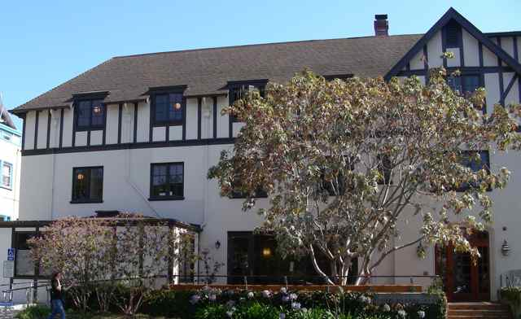

Sigma Phi Epsilon House from 1923 to 1938 at 2728 Durant

TILICUM CLUB (1913 to 1925)

Spring of 1914 until March 1925: The club, which was founded in December of 1913, and bought a house at 2605 Durant Avenue in 1914. The Tilicum club was closed in early 1918 during World War 1 and during the 1918-1919 school year. Tilicum club resumed operation in 1919 in this location. The Gamma Beta Chapter of Theta Upsilon Omega was initiated and chartered here.

THETA UPSILON OMEGA (1925 to 1938)

March 3, 1925 until winter 1927: TUO was established in the Tilicum Club house at 2605 Durant Ave. This house is still at that address, but it appears to have been rebuilt during the 1930's or 1940's.
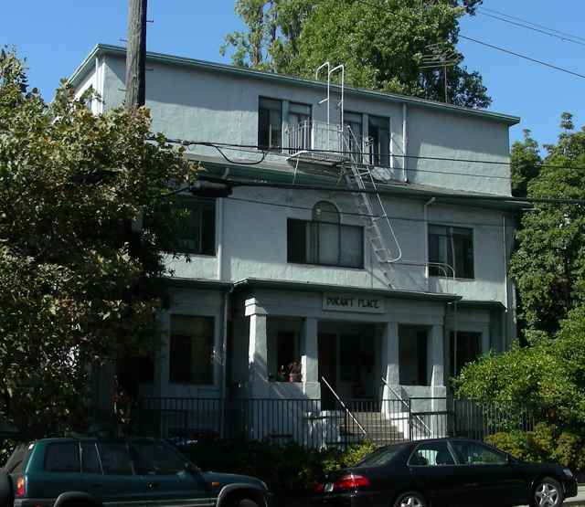

The Tilicum Club and Theta Upsilon Omega House from 1914 to 1927

Winter 1927 until Fall 1927: TUO rented a house at 2418 College. The planned to stay in this house until their new house on north side was finished. The lease was for one year. The site of this house is now a parking lot.

Fall of 1927 until Winter of 1928 TUO was apparently forced to move from the house they rented on College avenue. The new fraternity apparently lived at 2815 Bancroft for a short period of time while the new house on north side was being finished (according to TUO magazine “the Omegan”).

Winter of 1928 until the Winter of 1938: The fire of 1923 destroyed nine hundred structures north of Hearst and east of Oxford. In the immediate area of the campus, only dozen houses survived. TUO bought a lot on 2559 LeConte (east of Euclid) and built a new house. The depression hit TUO very hard, as it did Sigma Phi Epsilon and many other Greek organizations. The Greek system at Berkeley contracted from 103 groups in 1929 to about 75 groups in 1938, After TUO merged with Sigma Phi Epsilon, the merged fraternity moved into the TUO house during the winter of 1938 when TUO merged with Sigma Phi Epsilon.

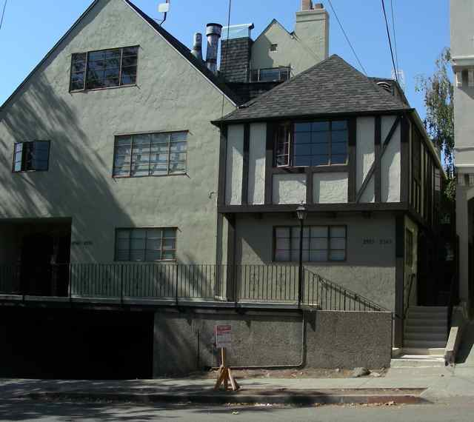

What is Left of the House at 2559 LeConte built by TUO in 1928. (This house was lost in 1939.)

SIGMA PHI EPSILON after the TUO merger (1938 on)

Winter 1938 until Summer 1939: The California Alpha chapter moved into the TUO house at 2559 LeConte after the merger of the two fraternities. This house was also lost to the bank. This house was merged with other houses along LeConte. The picture is what is left of the house at 2559 LeConte.

Fall 1939 until Fall 1945: The Sig Ep’s moved to a house at 2420 LeConte, a house formerly occupied by the ZTA sorority. Sig Ep spent the war years in this house. They were one of a handful of fraternities that remained open all during World War II. The site of this house is now occupied by one of the north side seminaries.

Fall 1945 until Spring 1950: The Sig Ep house was at 2731 Bancroft, a University owned house. It was said that this house had one of the best bars on campus. A long time Sig Ep cook Alma Gilson first went to work for Sig Ep in this house in 1949. The Sig Ep's were forced to move in 1950 and this house was physically moved to 2240 Piedmont Avenue to make room for new buildings for the Boalt law school. The law school now occupies the house.

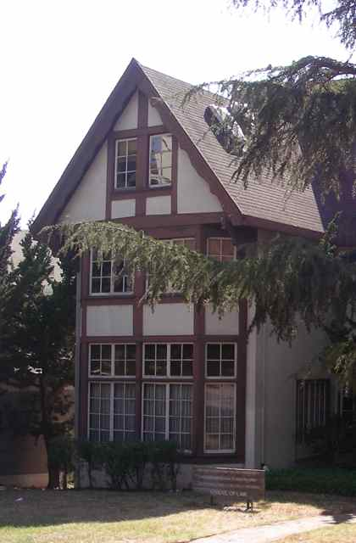

The House that was Occupied by Sigma Phi Epsilon from 1946 to 1950

Fall 1950 until Spring of 1951: The Sig Ep house was located at 2250 Hearst. Currently the site of this house is a large parking structure with tennis courts on top of it.

Fall 1951 until Spring of 1956: The Sig Ep's lived at 2714 Ridge Road. The Alpha Phi sorority built this house shortly after the turn of the century. This house was one of the few houses on the north side of campus to survive the 1923 fire. This firetrap was torn down in the early 1960's. Part of the Foothill dormitory complex occupies the site.

Fall 1956 until the Summer of 1968: In the fall of 1956, the chapter house was located at 2316 Bowditch in a house that was built in 1898. This house had housed a number of different fraternities over its long history, including Sigma Alpha Epsilon, Zeta Beta Tau, Delta Sigma Phi, Kappa Nu, Delta Tau Delta, Phi Kappa Psi, Alpha Sigma Phi and our fraternity. This house holds many memories for Cal Alpha Sig Ep's of the 1950's and 60's. Who can forget flooding the basement in this house? How many times did the pledges polish the ceiling in the living room of this house? Who can forget bad wiring, termites, fleas and roaches?

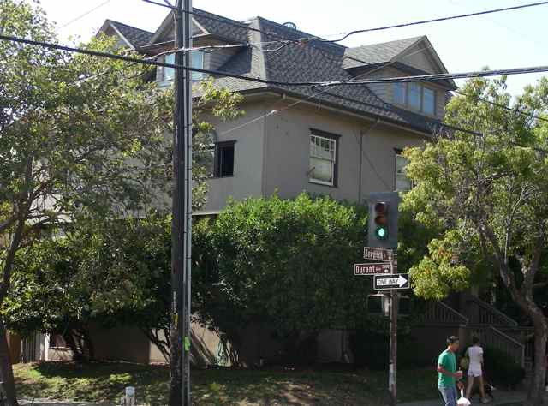

The Sigma Phi Epsilon House at 2316 Bowditch from 1956 to 1968 and 1984 to 1987

Fall 1968 until the Spring of 1969: The Chapter moved to the old Theta Upsilon house at 2732 Durant between the Kappa Kappa Gamma and Delta Zeta (the old Sig Ep house at 2728 Durant). Alma Gilson retired after 20 years of service as a cook when this house was closed.

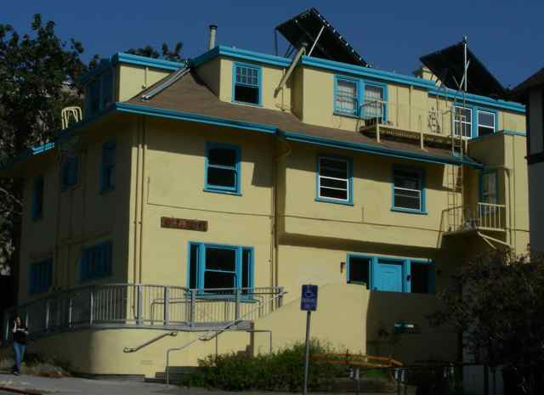

Sigma Phi Epsilon moved into this house at 2732 Durant in 1968. The chapter moved out in 1969.

Fall 1969 until Summer of 1984: Sig Ep went off campus sometime between 1969 and 1972. The chapter went officially dormant from 1972 until the fall of 1983 when Sigma Phi Epsilon re-colonized. The colony had no house until the summer of 1984.

Summer 1984 through the Spring of 1987: The chapter moved back to its old house at 2316 Bowditch in the summer of 1984. This old house had not changed except maybe the roaches were bigger. The chapter was re-chartered here on 3 November 1984. Believe it not, this house still stands. It is a seminary for a branch of the Episcopal Church that refuses to ordain women.

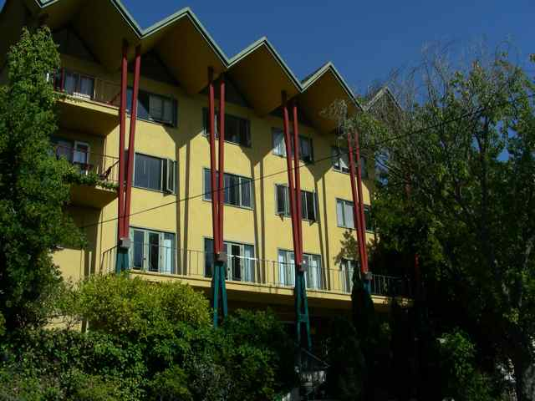

The Chapter House from 1987 to 1993 at 2425 Prospect

Spring 1987 through the August 1993: The chapter moved to a house built by Phi Mu in the early 1960's at 2425 Prospect. Our national fraternity bought this house. There was a battle with the city of Berkeley to get permission to use this house as it was zoned to be used. The house was put up for sale in the summer of 1993.

August 1993 until June 2000: California Alpha was housed in the historic Phi Gamma Delta house at 2395 Piedmont (on Channing Circle).

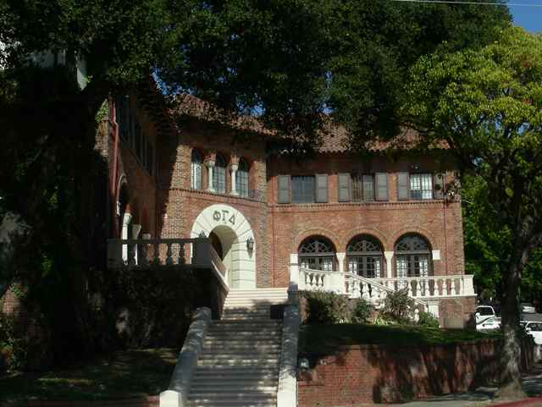

The Chapter occupied the Phi Gamma Delta house at 2395 Piedmont from 1993 to 2000
June 2000 to June 2005. California Alpha was without a house. The chapter turned in the charter in September of 2002. A Sigma Epsilon group was established in the spring of 2003.

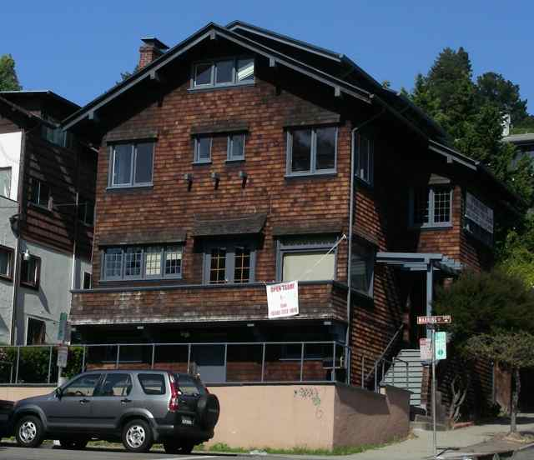

The California Alpha chapter occupied this house at 2901 Channing from 2005 to 2008.

June 2005 to June 2008: California Alpha was in a Julia Morgan house at 2901 Channing Way (on the north east corner of Channing and Warring).

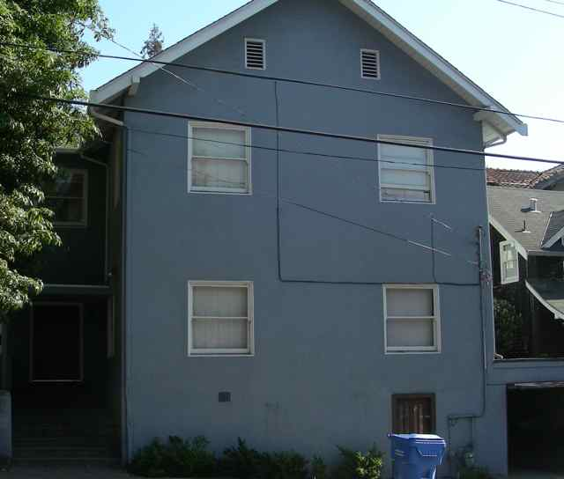

The Chapter House at 2708 Channing from the fall of 2008 until at least 2010

June 2008 on California Alpha was forced to move. They moved to a house at 2708 Channing Way (next to the Delta Gamma sorority). Despite having this house, California Alpha was named the best fraternity on the campus for the second year in a row.

